Lab 7 – PHP Part 2

More PHP and databases

Exercise 1: Downloading the contents of a database and displaying the details

The simplest SQL command is this:

Select * from Students

This command says select everything (*) from the table “student” in the database.

To display this in a web page use the following php code: -

<?php
$conn=mysqli_connect('localhost','yourloginname','yourpassword','yourdatabasename');
$sql="SELECT * FROM Students";
if (mysqli_connect_errno())
{
echo "Failed to connect to MySQL: " . mysqli_connect_error();
}
$rs=mysqli_query($conn,$sql);
if (!$rs)
{
die("Could not get data ".mysql_error());
}
while($row = mysqli_fetch_array($rs))
{
$studentname=$row['studentname'];
//read contents of Name field into variable studentname
$course=$row['course'];
$subject=$row['subject'];
echo ("<table>");
echo ("<tr><td>Name:</td><td>$studentname</td></tr>");
//write contents of variable studentname into an HTML table
echo ("<tr><td>Major:</td><td>$course</td></tr>");
echo ("<tr><td>Minor:</td><td>$subject</td></tr>");
echo ("</table>");
}
mysqli_close($conn); //close connection to database
?>

Exercise 1a

Change the data you display from the database to name, student number and date of birth for the same student. You will need to update your own database to add student number and date of birth fields and details (Use phpmyadmin to do this).

Exercise 2: Searching for a particular record

If you want to look for a particular record from a database instead of read the whole contents then use an IF statement instead of the WHILE statement.

Here is an example that uses two pages the first is an html page that accepts the record you are searching for and then when the submit button is clicked a php page searches the database: search_record.html

<html>
<head>
<title>Request data from form</title>
</head>
<body>
<form id="myform" method="post" action="php_read_record.php">
Name of student: <input type="text" id="studentname" name="studentname" />
<input type="submit">
</form>
</body>
</html>

File php_read_record.php, which is called in the action attached to the form, looks like this: -

<html>
<body>
<?php
$studentname = $_REQUEST['studentname']; //get the data from the form
$conn=mysqli_connect('localhost','yourloginname','yourpassword','yourdatabasename');
$sql="SELECT * FROM Students where studentname='$studentname' ";
if (mysqli_connect_errno())
{
echo "Failed to connect to MySQL: " . mysqli_connect_error();
}
$rs=mysqli_query($conn,$sql);
if (!$rs)
{
die("Could not get data ".mysql_error());
}
if ($row=mysqli_fetch_array($rs)) { //if there is an output
$course=$row['course'];
$subject=$row['subject'];
echo ("<table>");
echo ("<tr><td>Name:</td><td>".$studentname. "</td></tr>");
echo ("<tr><td>Course:</td><td>".$course."</td></tr>");
echo ("<tr><td>Subject:</td><td>".$subject."</td></tr>");
echo ("</table>");
}
else { //if there is no output
echo ("<p>Name not found</p>");
}
mysqli_close($conn); //close connection to database
?>
</body>
</html>

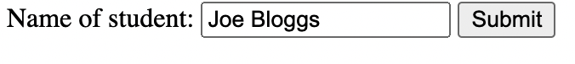

Note:
- This example assumes that only one record will be found, so should only be used to search on a primary key or a field with unique values. A loop would be needed if there is more than one record (as in the next exercise).
- Another problem with this example is that the user needs to know the exact student name. To get around this in the future we could produce a drop-down list from the database.
- Since the Name field has data type ‘text’, it needs quotes around its value in the SQL statement: where Name='$studentname'
- Other examples of SQL statements, for Number and Date fields, are:
$sql="SELECT Name, Height FROM [Student final] where Height>$studentHeight";
$sql="SELECT Name, DOB FROM [Student final] where DOB>#$studentDOB#";

On the form the DOB would have to be entered as month/day/year, eg 5/24/1985 (or separate text boxes or drop-down lists used for day, month, and year).

Exercise 3a – search the database
Now search the details for student Robin Banks and display the following information for that student – Name, DoB, Height, gender. You will have to add new fields and records to your database.

Exercise 4: Reading more than one selected records and displaying them all

Here we ask for a subject to be entered and then list the names of all the students doing that subject. As for the example above we need 2 pages: -

- An HTML page containing a form which asks the user for a subject to search for in the database.
- A PHP page which reads the subject, searches the database and displays the names of students with that subject. Here, we will need a loop to process all the names returned by the query.

The HTML form should look like this
<html>
<body>
<form method="post" action="php_read_multiple_records.php">
Major subject: <input type="text" name="major" />
<input type="submit">
</form>
</body>
</html>
PHP document (php_read_multiple_records.php)

<html>
<head></head>
<body>
<?php
$coursename = $_REQUEST['coursename']; //get the data from the form
$conn=mysqli_connect('localhost','yourloginname','yourpassword','yourdatabasename');
$sql="SELECT * FROM Students where course='$coursename' ";
if (mysqli_connect_errno())
{
echo "Failed to connect to MySQL: " . mysqli_connect_error();
}
$rs=mysqli_query($conn,$sql);
echo ("<p>Students majoring in $major:");
echo ("<table border='1'>"); //set up a table for the results
echo ("<tr><td>Name</td>");
echo ("<td>Course</td></tr>");
$found=0; //initialise variable to check if any records found
while ($row=mysqli_fetch_array($rs)) //loop through all the records returned
{
$found=1; //set variable because records found
$course=$row['course'];
$studentname=$row['studentname'];
echo ("<tr><td>".$studentname."</td><td>".$course."</td></tr>"); //put data in table
}
echo ("</table>"); //finish table
if ($found==0) { //print message if no data found
echo ("None found");
}
mysqli_close($conn); //close connection to database
?></body>
</html>

Exercise 4a – Select students using different criteria

Select all of the female or male students in the database

Exercise 5: Adding a new record to the Database

This page asks for a student name, gender (using radio buttons), course (using a check box), and subject (using a drop-down list) and creates a new record for the student in the database.

HTML page (php_add_record.htm)

<<form method="post" action="add_record.php">
<p>Name: <input type="text" name="studentname" /></p>
<p>Course B.Sc.: <input type="checkbox" name="course" /></p>
<p>Gender: <input type="radio" name="gender" value="F">Female
<input type="radio" name="gender" value="M">Male</p>
<p>Subject: <select name="subject">
<option value="Comp Sci">Computer Science
<option value="Design">Design
<option value="Arts">Arts
<option value="Business">Business
</select>
</p>
<input type="submit">
</form>
PHP page (add_record.php)

<?php
$studentname = $_REQUEST["studentname"]; //get the data from the form
if (isset($_REQUEST['course'])) {
$course="B.Sc.";
}
else {
$course="Not Degree";
}
$subject = $_REQUEST['subject'];
$gender = $_REQUEST['gender'];
$conn=mysqli_connect('localhost','xxxxx',xxxxx,'xxxxx');
$sql="INSERT INTO Students (studentname, gender, subject, course) VALUES ('$studentname','$gender','$subject','$course')";
if (mysqli_connect_errno())
{
echo "Failed to connect to MySQL: " . mysqli_connect_error();
}
if (mysqli_query($conn,$sql)) {
echo "Record added";
}
mysqli_close($conn); //close connection to database
?>

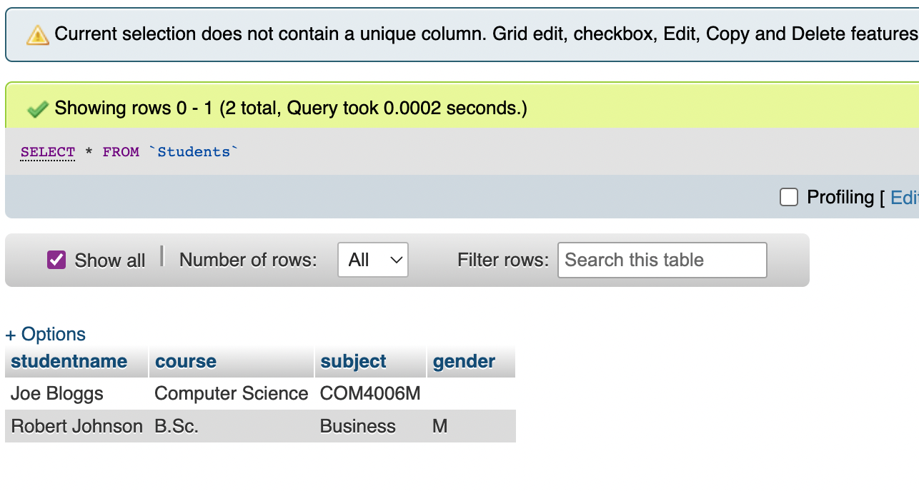
Note
- An error would occur if the gender was left blank (since $_REQUEST ['gender'] would not exist because no gender would be sent to the PHP page), so you really need some Javascript to make sure it has been filled in.
- If the course check box has not been ticked, no value is sent to the PHP page.
- The drop-down box will have the first option selected by default, so will always send a value to the PHP page.
- Single quotes are needed around text fields, but not Yes/No or Number fields, in the SQL statement.

Exercise 6: Updating a record
This page asks for the name of a student and the gender of the student, and updates the gender field of the student in the database.

HTML page (php_update.htm)
<form method="post" action="php_update.php">
<p>Name: <input type="text" name="studentname" />
<p>Gender: <input type="text" name="gender" />
<input type="submit">
</form>

This is the php to update the database

PHP page (php_update.php)

$studentname = $_REQUEST['studentname'];

$gender = $_REQUEST['gender'];

echo "$studentname";

echo "$gender";
$conn=mysqli_connect('localhost','yourloginname','yourloginpassword','yourdatabase');
$sql="UPDATE Students SET Gender='$gender' WHERE studentname='$studentname'";

echo $sql;

if (mysqli_query($conn,$sql)) {

echo "Record updated";

}

else {

echo "There was an error";

}

mysqli_close($conn); //close connection to database

Update the gender of the record that you have just added for the exercise above, for instance


Exercise 6a

Change the query to update the course field of the same record.

Exercise 7: Deleting a record
To delete a record send the following SQL once you have selected the record.

PHP page (delete.php)
<?php
$sql="DELETE FROM Students WHERE studentname='$studentname'";
?>

Delete the new record that you have created from the database.

Exercise 8: Creating an e-mail list
This exercise uses a new table within your database

Add a table called emaillist to your database, with the following fields:
- userid – AutoNumber – primary key – to number the records
- useremail – text – to store users' e-mail addresses
- username – text – to store users' names
To do use this table to generate an email requires 2 pages.

- An HTML page containing a form which asks the user for their name and e-mail address and submits these 2 fields to the PHP page
- A PHP page which reads the name and e-mail address, displays a 'thank you' message and sends a personalised e-mail to the user.

HTML page (php_email.htm)
<body>
<form id="emailform" name="emailform" method="post" action="php_email.php">
<p>Name: <input type="text" name="username" />
<p>E-mail: <input type="text" name="useremail" />
<input type="submit"></form></body>
PHP page (php_email.php)
<html>
<head></head>
<body>
<?php
//put the values from the form into variables
$username = $_REQUEST['username'];
$useremail = $_REQUEST['useremail'];
//add the new record
$conn=mysqli_connect('localhost','xxxx','yyyyy','zzzz');
$sql="INSERT INTO emaillist (useremail,username) VALUES ('$useremail','$username')";

if (mysqli_query($conn,$sql)) {
echo "<p>Thank you for entering your name and e-mail address. <br />";
echo "You have been added to our database. <br />";
echo "You should be receiving an e-mail shortly.</p>";
//set up mail parameters
$mailTo = $useremail; //e-mail address of the recipient
$msgSubject = "Message from PHP"; //subject of the e-mail
$msgBody = "Hi $username\nYou have been added to our database"; //e-mail message
$xHeaders = "From: server"; //e-mail address of sender
//send the e-mail (mail command takes 4 arguments)
mail ($mailTo, $msgSubject, $msgBody, $xHeaders);
}
?>
<p>Click <a href='php_email.html'>here</a> to return to previous page></p>
</body>
</html>

Note:
- \n puts a new line in the message.

Use the form to add some users to the database.

Exercise 8a
Change the form to ask for the user's title, first name and last name (or other information). Change the PHP page so that it sends a more formal e-mail (e.g. Dear Miss Small), update the header, from email address/details and the contents of the email message.

Add a section that also emails to your own address to notify you.

You should also think about how you might improve the form so that it validates the inputs. For example, checking for a valid email address being input.

